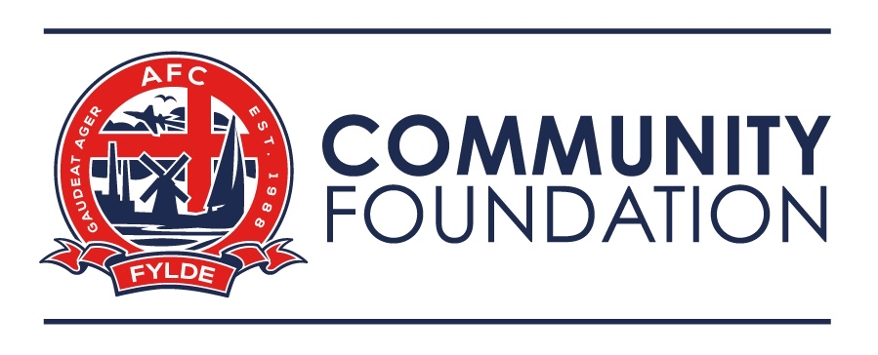

Complaints Policy
1 Policy Statement

1.1 The Company welcomes comments and feedback from all members of our community. We use this process to improve our services for stakeholders, fans and the wider community in which we exist.

1.2 The Company is committed to the continuous improvement of the services it provides. We recognise that, occasionally, mistakes may be made or that the service offered may not meet as individual’s requirements or expectations. For these reasons it is the Company’s policy that all complaints should be:

  - Received positively, treated seriously and in an open manner.
  - Acknowledged immediately, preferably in writing.
  - Investigated.
  - Resolved, wherever that is reasonably practicable, within no longer than 13 working weeks.
  - Treated as a source of learning with any feedback used to ensure continuous improvement of the services which the Company.

1.3 No person bringing a complaint under this procedure will be treated unfavourably in relation to their complaint by any member of staff. If there is evidence to the contrary, the member of staff may be subject to disciplinary proceedings.

  - For the purposes of this policy ‘the Company’ means AFC Fylde Community Foundation.

2 Scope

2.1 The policy applies to all members of our community but does not replace procedures for managing grievances, disciplinary and whistleblowing: those procedures should be used where appropriate by staff.

2.2 Any complaints or concerns raised which relate to an individual’s conduct or behaviour and have potential safeguarding implications for any child or vulnerable adult should be sent directly to the Head of Safeguarding. Where appropriate, these concerns will then be managed through the Company’s Safeguarding Children Policy or Safeguarding Adults Policy and procedures.

2.3 Complaints against the Head of Safeguarding or Senior Safeguarding Manager should be addressed to the Executive Chairman.

- How to make a complaint

  - If you wish to make a complaint, you can do so in person, by email or by letter.

  - If you need any reasonable adjustment making in relation to a disability to ensure you can register your complaint, you can contact us alternatively by:

- telephone (one of our members of staff will help you by writing out your complaint)
- asking a member of staff to help you in writing out your complaint
- asking a parent or advocate to register your complaint (this will apply to our learners and scholars)

  - Details of who to contact to make a complaint are provided below.

  - The company is not able to investigate anonymous complaints therefore to enable us to respond to your concern and improve our processes, please provide your name and contact details.

- How we will respond to your complaint
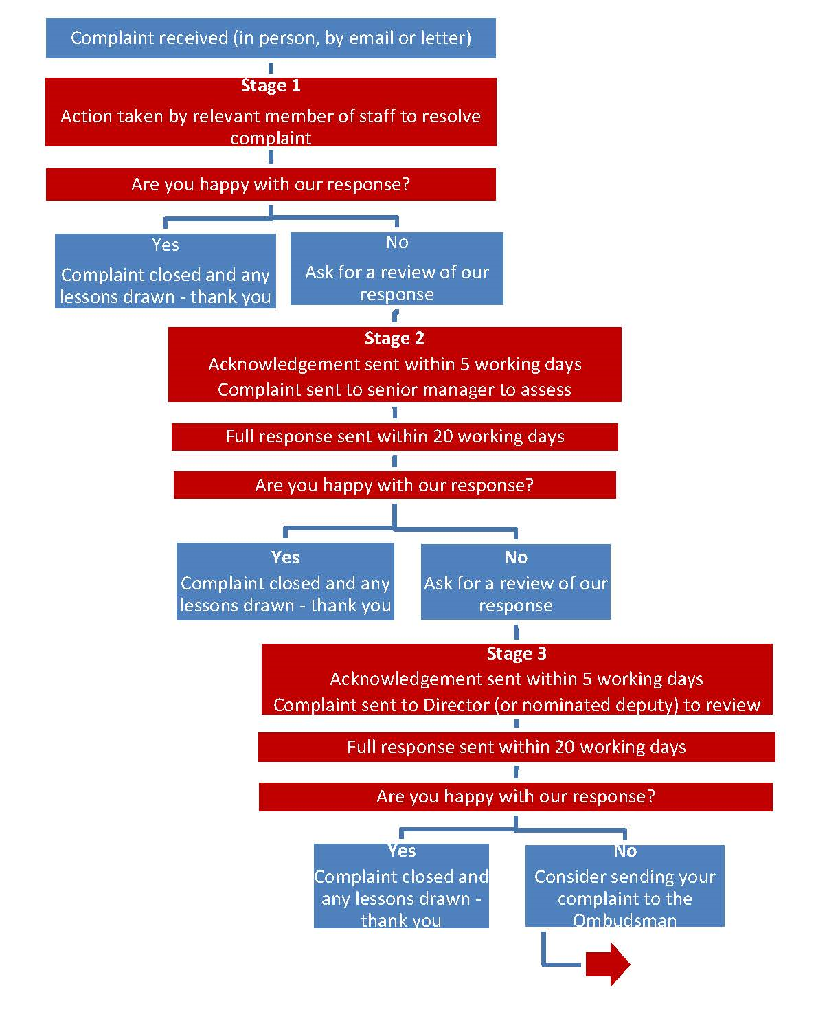

5 Process for managing complaints

We have a three-stage service complaints handling procedure, explained above. At each stage it will help us to resolve your complaint quickly if you can give us as much clarity and detail as possible, including providing any documents and correspondence and stating that you are making a complaint. If we do not have all the details required to deal with the complaint, we may contact you and ask you for further information.

5.1 Stage 1
This is the first opportunity for us to resolve your complaint. We expect the majority of complaints to be resolved at this stage. The member of staff who receives your complaint will seek to resolve this for you.

5.2 Stage 2
If you are dissatisfied with the response at Stage 1, you may request a review. This will be carried out by a senior manager. On receipt of your complaint we will contact a senior officer from the most appropriate business area and ask them to respond to your complaint.

5.3 Stage 3
If you are dissatisfied with the response at stage 2, you may request a review. This will be carried out by a responsible Director (or nominated senior manager not previously involved). Your request together with all subsequent correspondence relating to it should be sent to the appropriate person detailed in paragraph 8 below, who will forward your request to the relevant Director to be reviewed.

5.4 Stage 4
If having followed the three internal stages of our service complaints procedure you remain dissatisfied, you can ask to have your complaint reviewed by The Independent Football Ombudsman.

Complaints should be made in writing and may be submitted by post to:

The Independent Football Ombudsman
Suite 49
33 Great George Street,
Leeds
LS1 3AJ

Or by e-mail to: contact@theifo.co.uk
Or via the website: www.theifo.co.uk

6 Timescales

6.1 Our timescales for handling a complaint are as follows:

Stage 1 | We will respond immediately to any complaint raised in person (albeit this may only be an initial response and further investigations may be required).  Complaints received in writing will be responded to within 20 working days.
Stage 2 | We will acknowledge complaints within 5 working days of receiving each complaint. We will send a full response within 20 working days of receiving each complaint.
Stage 3 | We will acknowledge complaints within 5 working days of receiving each complaint. We will send a full response within 20 working days of receiving each complaint.

6.2 Extending time limits
We aim to complete our investigation into all complaints received about our service within the timescales set out above. However, in a limited number of cases - for example, if a complaint is very complex or requires further breakdown, it may be necessary to extend the time limit to ensure we have all the information necessary to deal with it. If this is the case we will keep you informed of progress with the investigation, the reasons for the delay, and inform you of next steps.

7 Recording complaints

Complaint details, outcomes and actions taken are recorded by us and used for service improvement. We record all complaints we receive and collate data from them to help us understand what types of problems are most prevalent, and how well we are doing to resolve them.

We value your feedback and expect to use it to help us to:
- get things right in the future if we have not done so already
- become more customer focused
- be more open and accountable
- act fairly and proportionately
- seek continuous improvement

We will handle your information so that it is only processed and retained appropriately and legally, in line with data protection legislation.

8 Contacting us

All complaints and requests for review under our complaints procedure should be sent as follows:
AFC Fylde Community Foundation |  | community@afcfylde.co.uk
 |  | 01772 598856
 |  | AFC Fylde Community Foundation, Fylde Sports and Education Centre, Coronation Way, Wesham, PR4 3JZ
AFC Fylde Football Club |  | info@afcfylde.co.uk
 |  | 01772 682593
 |  | AFC Fylde Football Club, Mill Farm Sports Village, Wesham, PR4 3JZ

9 Reasonable adjustments and alternative formats

The Company is committed to equal opportunities and our aim is to make our complaints policy easy to use and accessible to all of our customers. We will take reasonable steps to accommodate any reasonable adjustments you may need as a result of a disability to enable you to access this policy or receive responses to complaints in other formats, and provide such assistance as you may reasonably require.

10 Process for dealing with Unacceptable Behaviour from Complainants

10.1 The Company aims to provide a service that is responsive to the complaints made by fans, customers, participants, parents and carers or any other person who may use our services. However, the Company retains the right to respond appropriately, where we consider any person(s) behaviour to be unacceptable. We need to ensure that Company staff and other users of our services do not suffer any disadvantage from complainants who act in an unacceptable manner.

10.2 When we consider that the actions or behaviour of a complainant is unacceptable we will tell them why we find it unacceptable and we will give them the opportunity to modify their actions or behaviour. If the unacceptable actions or behaviour continue, we will take appropriate measures.

10.3 We have to take action when unreasonable actions or behaviour impair the functioning of the Company. We aim to do this in a way that, wherever possible, allows a complaint to progress through our process. We will try to ensure that any action we take is proportionate to the unacceptable actions or behaviour, taking into account any relevant personal circumstances of the complainant.

11 Vexatious complaints

11.1 The Company may reject a complaint at any time if, in the reviewer’s opinion, the complaint is considered “vexatious”. A frivolous or vexatious complaint can be characterised in a number of ways:
- Complaints which are obsessive, persistent, harassing, prolific, repetitious (Repetitious would include, for example, that after appropriate procedures have been followed and a full and final judgement has been provided the complainant continues to pursue the complaint)
- Insistence upon pursuing meritorious complaints in an unreasonable manner
- Insistence upon pursuing unmeritorious complaints and/or unrealistic outcomes beyond all reason
- Complaints which are designed to cause disruption or annoyance
- Demands for redress which lack any serious purpose or value

11.2 If we decide that a complainant’s complaint is vexatious, we will write to the complainant explaining that we are terminating our consideration of the complaint or further correspondence on the issue. We will give reasons for our decision.

11.3 Any complainant who is unhappy with the Company terminating consideration of a complaint due to unacceptable behaviour/vexatious reason has the right to submit a complaint to The Independent Football Ombudsman as detailed in point 5.4 of this policy.

12 Comments

Quality of service is an important measure for us of our effectiveness. Learning from complaints is a powerful way of helping continuous improvement at the Company and enable us to better deliver to our values and standards.

As well as learning from your complaints we are also interested in ideas you may have on how we might do things better. We would also like you to tell us when we do things well.

Your comments will be passed on to the relevant team and we will use them to help improve our service and the way we do things. You can make your comments by contacting any members of our staff, or you can e-mail community@afcfylde.co.uk.

