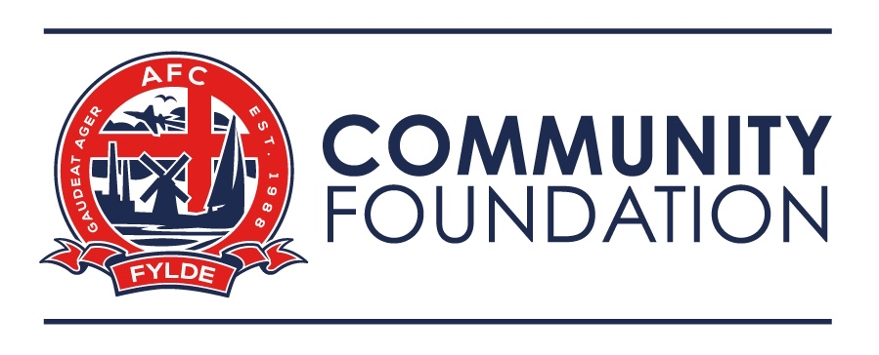

Whistleblowing Policy

Overview

  - This policy outlines what you should do if you suspect wrongdoing or dangers in relation to the Company’s activities.

  - It applies to all employees, contractors, volunteers, consultants, officers, interns, casual and agency workers of the company. It does not form part of any employee’s contract of employment or any other contractual terms and can be amended at any time.

  - For the purposes of this policy ‘the Company’ means AFC Fylde Community Foundation.

What is whistleblowing?

  - ‘Whistleblowing’ is the reporting of suspected wrongdoing or dangers in relation to our activities. Our aim is to maintain the highest standards of integrity in everything we do, but any organisation can occasionally be affected by conduct that is dangerous, against the law or breaches ethical or professional codes. Should you have such concerns, we encourage you to report them immediately. You can be assured that we will take your concerns seriously, that they will be thoroughly investigated, and that there will be no reprisals for you.

  - The types of suspected wrongdoing or dangers at work that you may want to raise with us include:

    - any activity you suspect is criminal or fraudulent
    - any activity you suspect puts health and safety at risk
    - any activity you suspect does not safeguard children or vulnerable adults
    - any activity you suspect may damage the environment
    - any activity you suspect is a miscarriage of justice
    - any activity you suspect breaches our policy on bribery and corruption
    - any failure to comply with legal or regulatory obligations
    - any failure to meet professional requirements
    - any attempt to conceal one or more of these activities.

  - You are encouraged to speak to your manager or the Head of HR if you are not sure whether something you have become aware of is covered by this policy. Please note that this policy does not cover anything to do with you personally, such as how other people are treating you, for example. For this, please refer to our Anti Harassment and Bullying Policy and our Grievance Policy for guidance on how to proceed.

How to raise a whistleblowing concern

  - In most cases, you should start by raising your concerns with your manager, either face- to-face or in writing.

  - If you would prefer not to raise it with your manager, or your manager fails to address all your concerns, you should write to or arrange to meet with the Foundation Director. You should also report your concerns to the Foundation Director if they are of a very serious nature.

  - If your concern relates to the safeguarding of children or vulnerable adults you should raise it with the Head of Safeguarding.

  - If you report your concerns in writing, you should specify that you are raising your concerns under this policy and explain what the concerns are. Please set out the basis for your concerns including all the key facts, dates, and the names of the people you believe are involved.

  - You will be invited to a meeting to discuss your concerns.

  - After the initial meeting, we will investigate your concerns and we may ask you to attend further meetings. To investigate properly, we may involve specialists with particular knowledge or experience of the issues you have raised.

  - We will try to keep you informed about our investigations. Sometimes, however, we may be unable to give you details about the investigation (or any action it leads to) as we need to protect confidentiality. We understand this may be frustrating, and if this happens we will do our best to sit down with you and explain why we are acting in the way we are.

Confidentiality and anonymity

  - We hope that staff feel able to voice whistleblowing concerns openly under this policy. We actively discourage anonymous whistleblowing as it makes complaints difficult to investigate and we may not be able to establish if your allegations are credible.

  - If you prefer to raise your concern in confidence, we will make every effort to ensure your identity remains hidden. We may want to disclose your identity to people involved in the investigation, but will always inform of this first.

  - You are protected from reprisals under this policy (see paragraph 5), but if you are still worried, we encourage you to discuss this with the Foundation Director who will explore how far we can go in keeping your concerns confidential.

How we protect whistleblowers

  - If you raise a genuine concern under this policy, we will support you fully even if our investigations conclude that you are mistaken. If you feel you have been treated detrimentally as a result of raising a whistleblowing concern, you must tell us at once. First inform your manager and, if the matter remains unresolved, you must follow the formal process in our Grievance Procedure.

  - All whistleblowers are afforded the same protection, so you must not threaten or retaliate against others who have raised whistleblowing concerns. You may face disciplinary action if we suspect that you have.

  - You can seek further advice on whistleblowing, protecting confidentiality, and being protected from reprisals from the independent charity Public Concern at Work, which offers a confidential helpline on 020 7404 6609; www.pcaw.org.uk.

Taking your concerns outside the Company

  - This policy outlines the process for raising, investigating, and resolving whistleblowing concerns within the workplace. It is rarely necessary – or, from our point of view, desirable – for anyone outside the Company to become involved when a whistleblowing allegation is made.

  - In some exceptional circumstances, you may need to go to an external body such as an industry regulator. We strongly encourage you to seek advice before reporting a concern to anyone external. The independent charity, Public Concern at Work (contact details in paragraph 5.3) operates a confidential helpline which can be used for this purpose.

  - This policy covers the actions of third parties such as suppliers, service providers, and clients, as well as our staff. Should you have concerns about a third party, you are encouraged to raise them with us before approaching anyone else. Your manager or the Head of HR will be able to explain how you should proceed.

  - Alerting the media to a concern, particularly before or during an internal investigation, is almost never justified or appropriate in any situation. We strongly discourage you from doing so, and will treat any contact with the press as a serious disciplinary issue justifying dismissal unless exceptional circumstances exist. We would normally expect you to have taken all reasonable steps to deal with the matter internally or with an external regulator, and to have taken full advice from a lawyer or Public Concern At Work before approaching the press.

